TEST
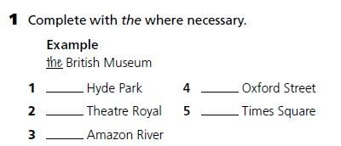

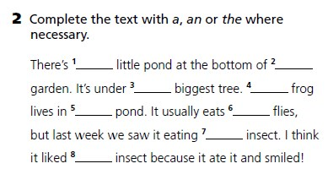

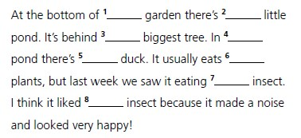

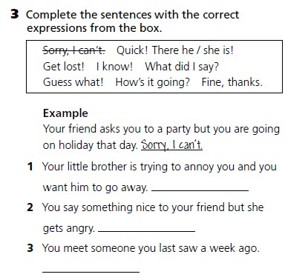

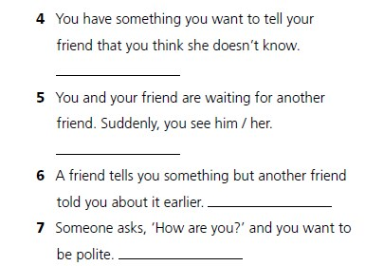

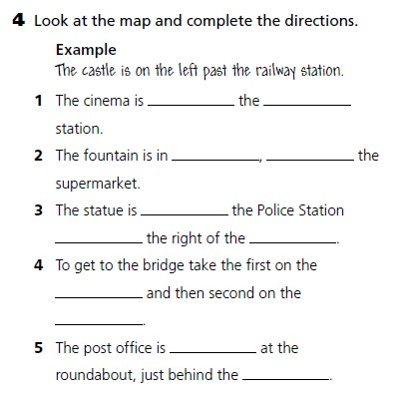
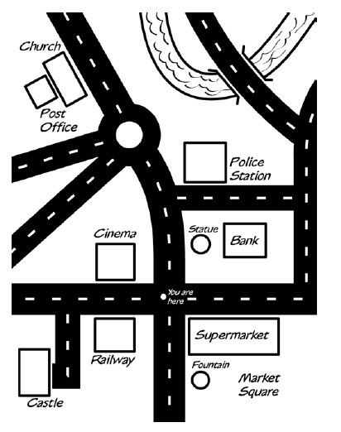
Pomoć u 4. zadatku:
1) o_____ the r______,
2) M _______, n _______
3) o _______ , on , b _____
4 ) l _______ l _______
5) s _________ ahead , c_______

5. Complete the sentences with a correct pronoun (somebody, anybody....)

1) Does ____________ want to play tennis this morning?
2) What’s that smell? I think ______________ is burning.
3) I have _____________ more to say to you. Good Bye !
4) I felt strange. I was sure that ______________ was looking at me.
5) It was Sunday morning and the town was deserted (opustošen). _______________ was in the streets and ______________ was open.
6) Our holiday was perfect. ______________ went as we wished.
7) Why are you looking at me so angrily? I didn’t do ______________ wrong.
8) My dictionary was on the desk. _______________ has taken it.

6. Complete the sentences with the verbs in brackets in Present ContinuousTense

1) I ________________ (meet) Jim at the airport tomorrow.
2) We _________________ (have) a test next Monday.
3) They _________________ ( not leave) school until August.
4) My brother ________________ (play) online games with his friends tonight.
5) _________ you __________ (have) a party for your birthday?
6) He _______________ (do) his homework after lunch.
7) I ______________ (not go) to the cinema at the weekend.

